BANK CHURN ANALYSIS
Database Used - MySQL Server DB
This project aims to analyse bank customer data to uncover insights about financial behaviour, credit utilization, income patterns, and risk assessment. Instead of focusing on churn or retention, the project emphasizes:
The Banking and Financial Analytics domain revolves around using data-driven insights to optimize banking operations, enhance customer experience, and mitigate risks. Banks collect vast amounts of data from customer transactions, credit histories, and financial behaviour, which are analysed to make informed business decisions.
In this domain, various analytical techniques are used to understand customer segmentation, assess credit risk, detect fraud, and improve financial product offerings. The primary goal is to enhance financial stability while maximizing customer retention and profitability.
- Customer Segmentation (by age, income, education, and credit behaviour)
- Credit Utilization & Risk Analysis
- Spending Behaviour & Financial Health
- High-Value Customer Identification
- Dormant & High-Risk Accounts
By leveraging SQL queries, we can generate key performance indicators (KPIs) that help banks make data-driven decisions for personalized services, risk mitigation, and marketing strategies.
Business Impact:
- Better Credit Risk Management – Identify high-risk customers before they default.
- Personalized Banking Services – Offer premium services to high-net-worth individuals.
- Marketing Optimization – Focus on high-potential customers for financial products.
- Enhanced Customer Retention Strategies – Detect dormant accounts & re-engage customers.

KPI’s Requirements:
- Total Customers:
SELECT COUNT(clientnum) AS Total_Customers FROM churn
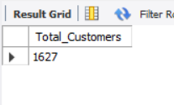

- Average Utilization Ratio:
SELECT ROUND(AVG(utilization_ratio), 2) AS Avg_Utilization
FROM churn

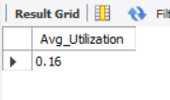

- Average Credit Limit:
SELECT ROUND(AVG(credit_limit),2) AS Avg_Credit_Limit FROM churn
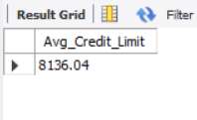

- Average Age:
SELECT FLOOR(AVG(customer_age)) AS Avg_Age FROM churn;
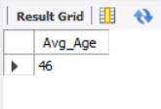

GRANULAR ANALYSIS
- Customer Distribution by Card Category

SELECT card_category, COUNT(clientnum) AS Customer_Count
FROM churn
GROUP BY card_category
ORDER BY Customer_Count DESC;

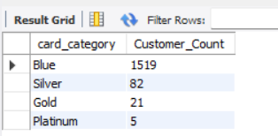

- Average Balance by Income Level

SELECT income, AVG(balance) AS Avg_Balance
FROM churn
GROUP BY income
ORDER BY Avg_Balance DESC;

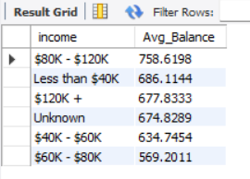

- Customers by Marital Status

SELECT marital_status, COUNT(clientnum) AS Customer_Count
FROM churn
GROUP BY marital_status
ORDER BY Customer_Count DESC;

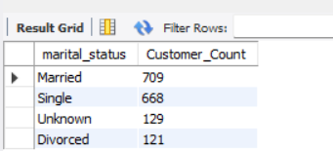
- Customers Segmentation by Age Group

SELECT
CASE
WHEN customer_age BETWEEN 18 AND 25 THEN '18-25'
WHEN customer_age BETWEEN 26 AND 35 THEN '26-35'
WHEN customer_age BETWEEN 36 AND 45 THEN '36-45'
WHEN customer_age BETWEEN 46 AND 55 THEN '46-55'
ELSE '56+'
END AS Age_Group,
COUNT(clientnum) AS Total_Customers
FROM churn
GROUP BY CASE
WHEN customer_age BETWEEN 18 AND 25 THEN '18-25'
WHEN customer_age BETWEEN 26 AND 35 THEN '26-35'
WHEN customer_age BETWEEN 36 AND 45 THEN '36-45'
WHEN customer_age BETWEEN 46 AND 55 THEN '46-55'
ELSE '56+'
END
ORDER BY Total_Customers DESC;

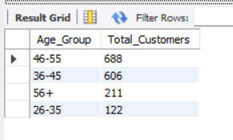

- Highest Credit Utilization Customers (Top 10)

SELECT TOP 10
clientnum,
customer_age,
income,
credit_limit,
utilization_ratio
FROM churn
ORDER BY utilization_ratio DESC;

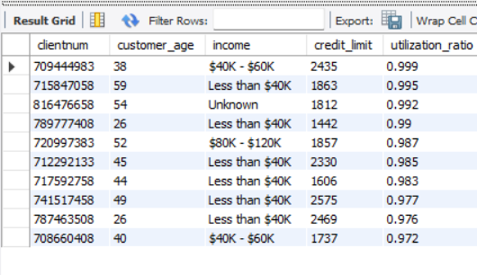
- Customers with High Credit Limit but Low Balance (Top 10)

SELECT TOP 10
clientnum,
customer_age,
income,
credit_limit,
balance,
ROUND((balance * 100.0 / credit_limit), 2) AS Balance_Percentage
FROM churn
WHERE balance < (0.2 * credit_limit)
ORDER BY Balance_Percentage ASC;

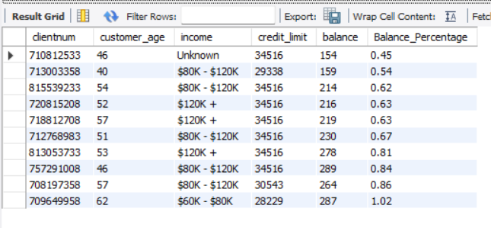

- Customers with the Longest Relationship (Top 10 by Tenure)

SELECT TOP 10
clientnum,
customer_age,
months_on_book,
income,
balance
FROM churn
ORDER BY months_on_book DESC;
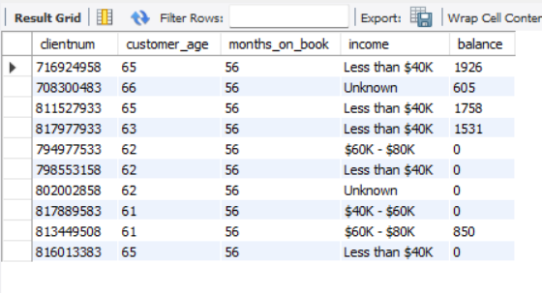

- Average Dependent Count by Income Group

SELECT
income,
ROUND(AVG(dependent_count), 2) AS Avg_Dependents
FROM churn
GROUP BY income
ORDER BY Avg_Dependents DESC;

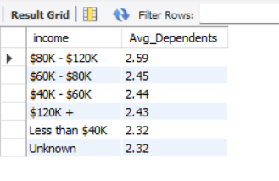

- Credit Utilization Index (High-Risk Customers)

SELECT
clientnum,
customer_age,
income,
credit_limit,
utilization_ratio,
ROUND((utilization_ratio * 100.0), 2) AS Utilization_Percentage,
CASE
WHEN utilization_ratio > 0.8 THEN 'High Risk'
WHEN utilization_ratio BETWEEN 0.5 AND 0.8 THEN 'Moderate Risk'
ELSE 'Low Risk'
END AS Risk_Level
FROM churn
ORDER BY utilization_ratio DESC;

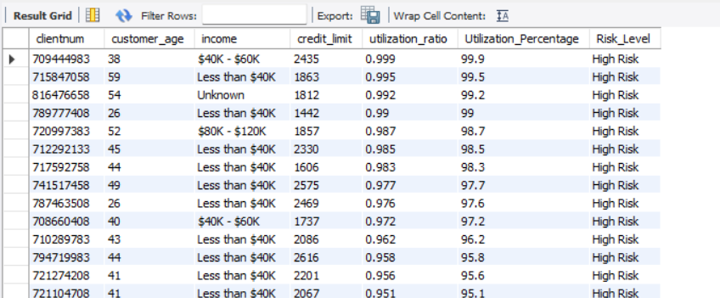
- Longest Relationship Customers (VIP Segmentation)

SELECT
clientnum,
customer_age,
months_on_book,
income,
balance,
credit_limit
FROM churn
WHERE months_on_book > 53
ORDER BY balance DESC;

